
CENTRAL BOARD OF SECONDARY EDUCATION


JAWAHAR NAVODAYA VIDYALAYA
TARIKHET ALMORA UTTARAKHAND 263663

COMPUTER SCIENCE (083)
PROJECT FILE
On
LIBRARY MANGEMENT SYSTEM USING PICKLE MODULE
SESSION: 2026-27
SUBMITTED BY :

S. No | Name | CBSE Roll
CLASS : XII
SECTION : SCIENCE

PRINCIPAL
(PANKAJ KUMAR SRIVASTAVA)

INTERNAL EXAMINER
(PANKAJ BHILINGWAL)

EXTERNAL EXAMINER

ACKNOWLEDGEMENT

I wish to express my deep sense of gratitude and indebtedness to our learned teacher Pankaj Bhilingwal, PGT Computer Science, J.N.V Tarikhet Almora for his invaluable help, advice and guidance in the preparation of this project file.
I am also greatly indebted to our principal Pankaj Kumar Srivastava and school authorities for providing me with the facilities and requisite laboratory conditions for making this project file.
I also extend my thanks to a number of teachers, my classmates and friends who helped me to complete this project file successfully.
NAME :

S. No | Name | CBSE Roll

CLASS : XII
SECTION : SCIENCE

CERTIFICATE

This is to certify that,
S. No | Name | CBSE Roll

Student of Class XII, J.N.V Tarikhet Almora has completed the PROJECT FILE during the academic year 2026-27 towards partial fulfilment of credit for the Computer Science Project evaluation of CBSE and submitted satisfactory report, as compiled in the following pages, under my supervision.

Internal Examiner External Examiner
Signature Signature

PREFACE

This project report details the development of a Library Management System using Python. The project is designed to automate the management of a school library, allowing the librarian to perform operations such as adding books, registering students, issuing and returning books, and tracking each student’s issued and returned books. The project highlights Python's powerful data-handling capabilities, especially using the Pickle module for data persistence. The project aims to simplify and improve the efficiency of library operations.
I also feel that it is the right time to thank my teacher, who guided me during my project. I also feel that it is the right time to thank my parents, friends and my project partners for their constant assistance, cooperation extended by them time to time.

Table of Contents
About Project 5
Introduction: 5
Programming Language: 5
Modules Used: 5
How to Run the Program: 5
System Features 5
1. Librarian Authentication 5
2. Student Registration 5
3. Book Management 5
4. Book Issuing and Returning 5
5. Tracking Issued and Returned Book 6
User Interaction: 6
1. Librarian Login: 6
2. Menu Options: 6
3. Student Registration: 6
4. Book Issuing: 6
5. Book Return: 6
Flow Chart 7
Project Code 8
Output 16
Technological requirements 19
Software 19
Hardware 19
References 20

About Project

Introduction:
The Library Management System is a Python-based project designed to automate library operations. This system allows the librarian to add and remove books, register students, issue books, and manage book returns. The system also tracks how many books a student has issued or returned. Data is saved using Python’s Pickle module, ensuring the information persists between program runs.

Programming Language:
The project is implemented using the Python programming language, known for its simplicity and versatility. Python's ease of use makes it an ideal choice for developing interactive and enjoyable games.

Modules Used:
- Pickle Module: To store and load library and student data.
- UUID Module: To generate unique IDs for students.
- OS Module: To handle file operations.

How to Run the Program:
- Open the terminal or command prompt.
- Navigate to the directory where the Python script is saved.
- Run the script using the command:
python library_management_system.py
The system will prompt the user for librarian authentication before allowing any operations.

System Features

Librarian Authentication
Only the librarian with a valid username and password can access the system.

Student Registration
Students are registered with their name, roll number, class, section, gender, and date of birth. Each student is assigned a unique student ID.

Book Management
Books can be added and removed by the librarian.

Book Issuing and Returning
Registered students can issue books. The system ensures that:
  - A student can issue a maximum of 10 books at a time.
  - The same book cannot be issued twice unless it is returned.
  - Only books available in the library can be issued. After issuing a book, the system prompts if the student wants to issue another book.

Tracking Issued and Returned Book
The system tracks the number of books issued and returned by each student.

User Interaction:

Librarian Login:
The librarian needs to authenticate with a username and password to access the system.

Menu Options:
The system displays a menu with options such as registering students, adding books, issuing books, etc.

Student Registration:
The librarian enters the student's details, and the system generates a unique student ID.

Book Issuing:
The librarian enters the student ID and book ID. The system checks if the book is available and issues it to the student.

Book Return:
The librarian enters the student ID and book ID to return the book.

Flow Chart

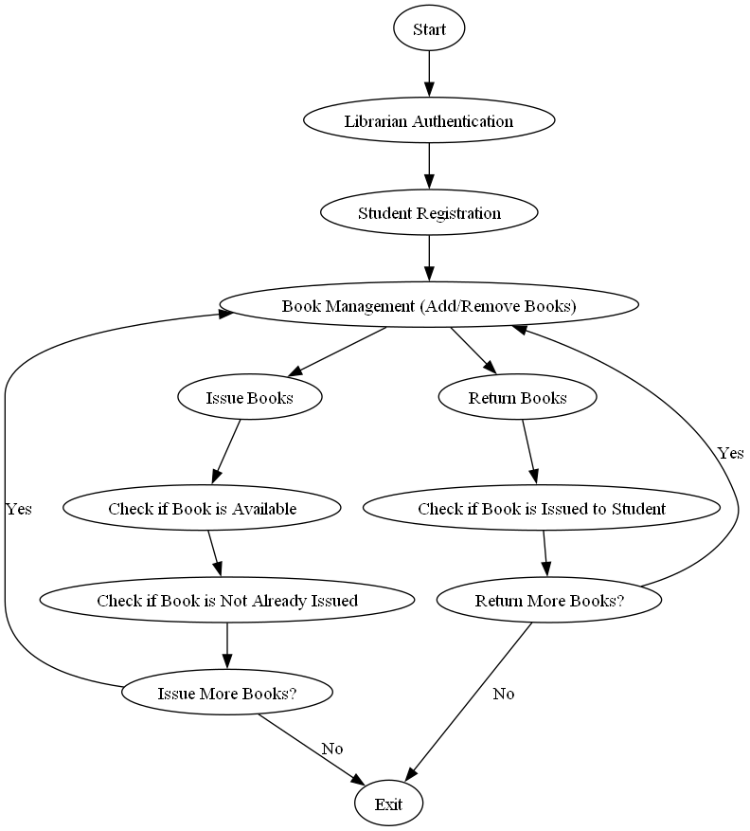

Project Code

import pickle
import os
import uuid # For generating unique student IDs

# Files to store library and student data
library_data_file = 'library_data.pkl'
students_data_file = 'students_data.pkl'

# Librarian credentials (can be hardcoded for simplicity)
LIBRARIAN_USERNAME = "Pankaj"
LIBRARIAN_PASSWORD = "qwer"

# Function to load data from a pickle file
def load_data(file):
if os.path.exists(file):
with open(file, 'rb') as f:
return pickle.load(f)
else:
return {}

# Function to save data to a pickle file
def save_data(data, file):
with open(file, 'wb') as f:
pickle.dump(data, f)

# Function to register students with extended details and auto-generated ID
def register_student():
students = load_data(students_data_file)

name = input("Enter Student Name: ")
roll = input("Enter Roll Number: ")
student_class = input("Enter Class: ")
section = input("Enter Section: ")
gender = input("Enter Gender (M/F): ")
dob = input("Enter Date of Birth (DD-MM-YYYY): ")

# Generate a unique student ID
student_id = str(uuid.uuid4())[:8] # Using first 8 characters of UUID as student ID

# Register the student with details
students[student_id] = {
'name': name,
'roll': roll,
'class': student_class,
'section': section,
'gender': gender,
'dob': dob,
'issued_books': [],
'books_returned': 0
}

save_data(students, students_data_file)
print(f"Student '{name}' registered successfully with Student ID: {student_id}")

# Function to authenticate librarian
def authenticate_librarian():
username = input("Enter librarian username: ")
password = input("Enter librarian password: ")

if username == LIBRARIAN_USERNAME and password == LIBRARIAN_PASSWORD:
print("Librarian authenticated successfully!")
return True
else:
print("Authentication failed! Invalid username or password.")
return False

# Function to add a book to the library
def add_book(book_id, title, author):
library = load_data(library_data_file)
if book_id in library:
print(f"Book with ID {book_id} already exists!")
else:
library[book_id] = {'title': title, 'author': author, 'is_issued': False, 'issued_to': None}
save_data(library, library_data_file)
print(f"Book '{title}' added successfully!")

# Function to remove a book from the library
def remove_book(book_id):
library = load_data(library_data_file)
if book_id in library:
del library[book_id]
save_data(library, library_data_file)
print(f"Book ID {book_id} removed successfully!")
else:
print(f"Book with ID {book_id} not found!")

# Function to issue a book to a registered student, checking conditions
def issue_book(student_id):
library = load_data(library_data_file)
students = load_data(students_data_file)

if student_id not in students:
print(f"Student with ID {student_id} is not registered!")
return

student = students[student_id]

# Check if the student has already issued the maximum of 10 books
if len(student['issued_books']) >= 10:
print(f"Student {student['name']} has already issued the maximum of 10 books!")
return

while True:
book_id = input("Enter Book ID to issue: ")

if book_id not in library:
print(f"Book with ID {book_id} not found!")
return

if library[book_id]['is_issued']:
print(f"Book ID {book_id} is already issued to {library[book_id]['issued_to']}!")
return

if book_id in student['issued_books']:
print(f"Student {student['name']} has already issued this book.")
return

# Issue the book
library[book_id]['is_issued'] = True
library[book_id]['issued_to'] = student['name']
student['issued_books'].append(book_id)

save_data(library, library_data_file)
save_data(students, students_data_file)

print(f"Book ID {book_id} issued successfully to {student['name']}!")

# Ask if the student wants to issue more books
issue_more = input("Do you want to issue another book? (Y/N): ").strip().upper()
if issue_more != 'Y':
break

# Function to return a book by a student
def return_book(book_id, student_id):
library = load_data(library_data_file)
students = load_data(students_data_file)

if book_id not in library:
print(f"Book with ID {book_id} not found!")
return

if not library[book_id]['is_issued']:
print(f"Book ID {book_id} is not issued!")
return

if student_id not in students:
print(f"Student with ID {student_id} not registered!")
return

student = students[student_id]

if book_id not in student['issued_books']:
print(f"Student {student['name']} did not issue this book.")
return

# Return the book
library[book_id]['is_issued'] = False
library[book_id]['issued_to'] = None
student['issued_books'].remove(book_id)
student['books_returned'] += 1

save_data(library, library_data_file)
save_data(students, students_data_file)

print(f"Book ID {book_id} returned successfully by {student['name']}!")

# Function to display all books
def display_books():
library = load_data(library_data_file)
if library:
for book_id, book_info in library.items():
status = 'Issued' if book_info['is_issued'] else 'Available'
issued_to = book_info['issued_to'] if book_info['is_issued'] else 'N/A'
print(f"Book ID: {book_id}, Title: {book_info['title']}, Author: {book_info['author']}, Status: {status}, Issued To: {issued_to}")
else:
print("No books in the library.")

# Function to display all registered students
def display_students():
students = load_data(students_data_file)
if students:
print("Registered Students:")
for student_id, student_info in students.items():
print(f"Student ID: {student_id}, Name: {student_info['name']}, Class: {student_info['class']}, Section: {student_info['section']}, Issued Books: {len(student_info['issued_books'])}, Books Returned: {student_info['books_returned']}")
else:
print("No students registered.")

# Main Program
if __name__ == "__main__":
if authenticate_librarian(): # Only proceed if librarian is authenticated
while True:
print("\nLibrary Management System")
print("1. Register Student")
print("2. Add Book")
print("3. Remove Book")
print("4. Issue Book")
print("5. Return Book")
print("6. Display Books")
print("7. Display Students")
print("8. Exit")

choice = input("Enter your choice: ")

if choice == '1':
register_student()

elif choice == '2':
book_id = input("Enter Book ID: ")
title = input("Enter Book Title: ")
author = input("Enter Book Author: ")
add_book(book_id, title, author)

elif choice == '3':
book_id = input("Enter Book ID to remove: ")
remove_book(book_id)

elif choice == '4':
student_id = input("Enter Student ID: ")
issue_book(student_id)

elif choice == '5':
book_id = input("Enter Book ID to return: ")
student_id = input("Enter Student ID: ")
return_book(book_id, student_id)

elif choice == '6':
display_books()

elif choice == '7':
display_students()

elif choice == '8':
print("Exiting...")
break

else:
print("Invalid choice! Please try again.")

Output

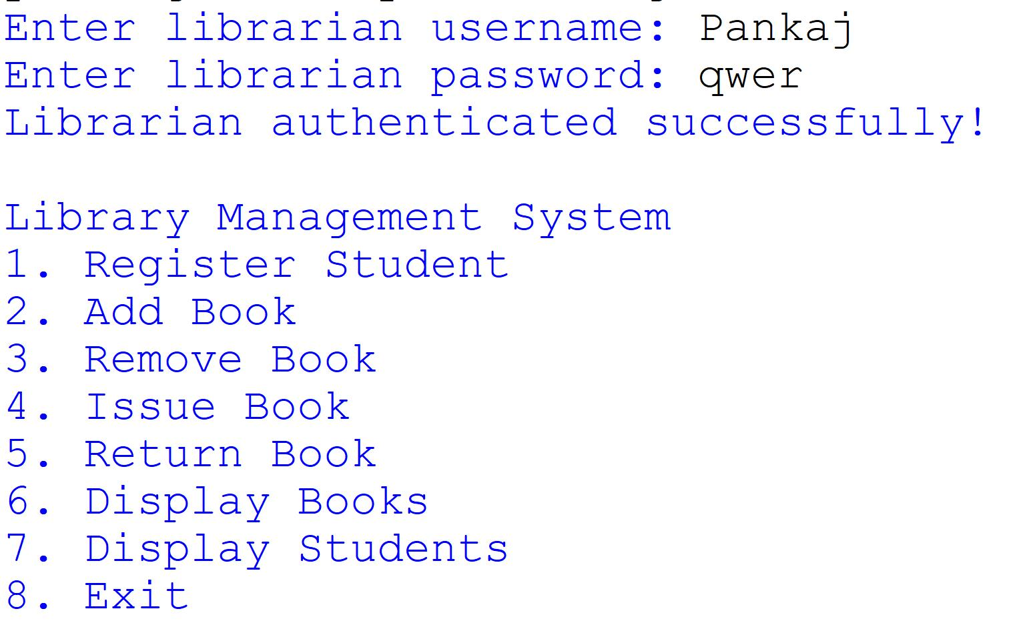
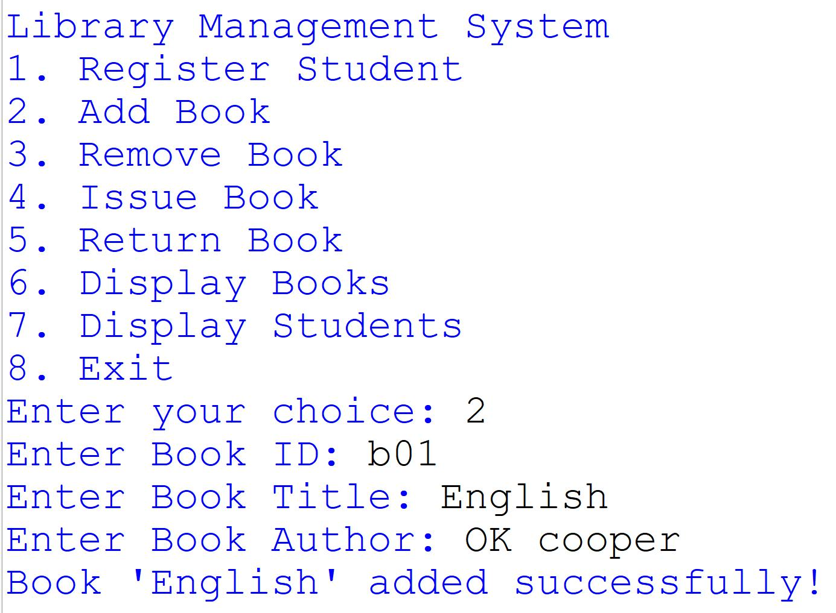
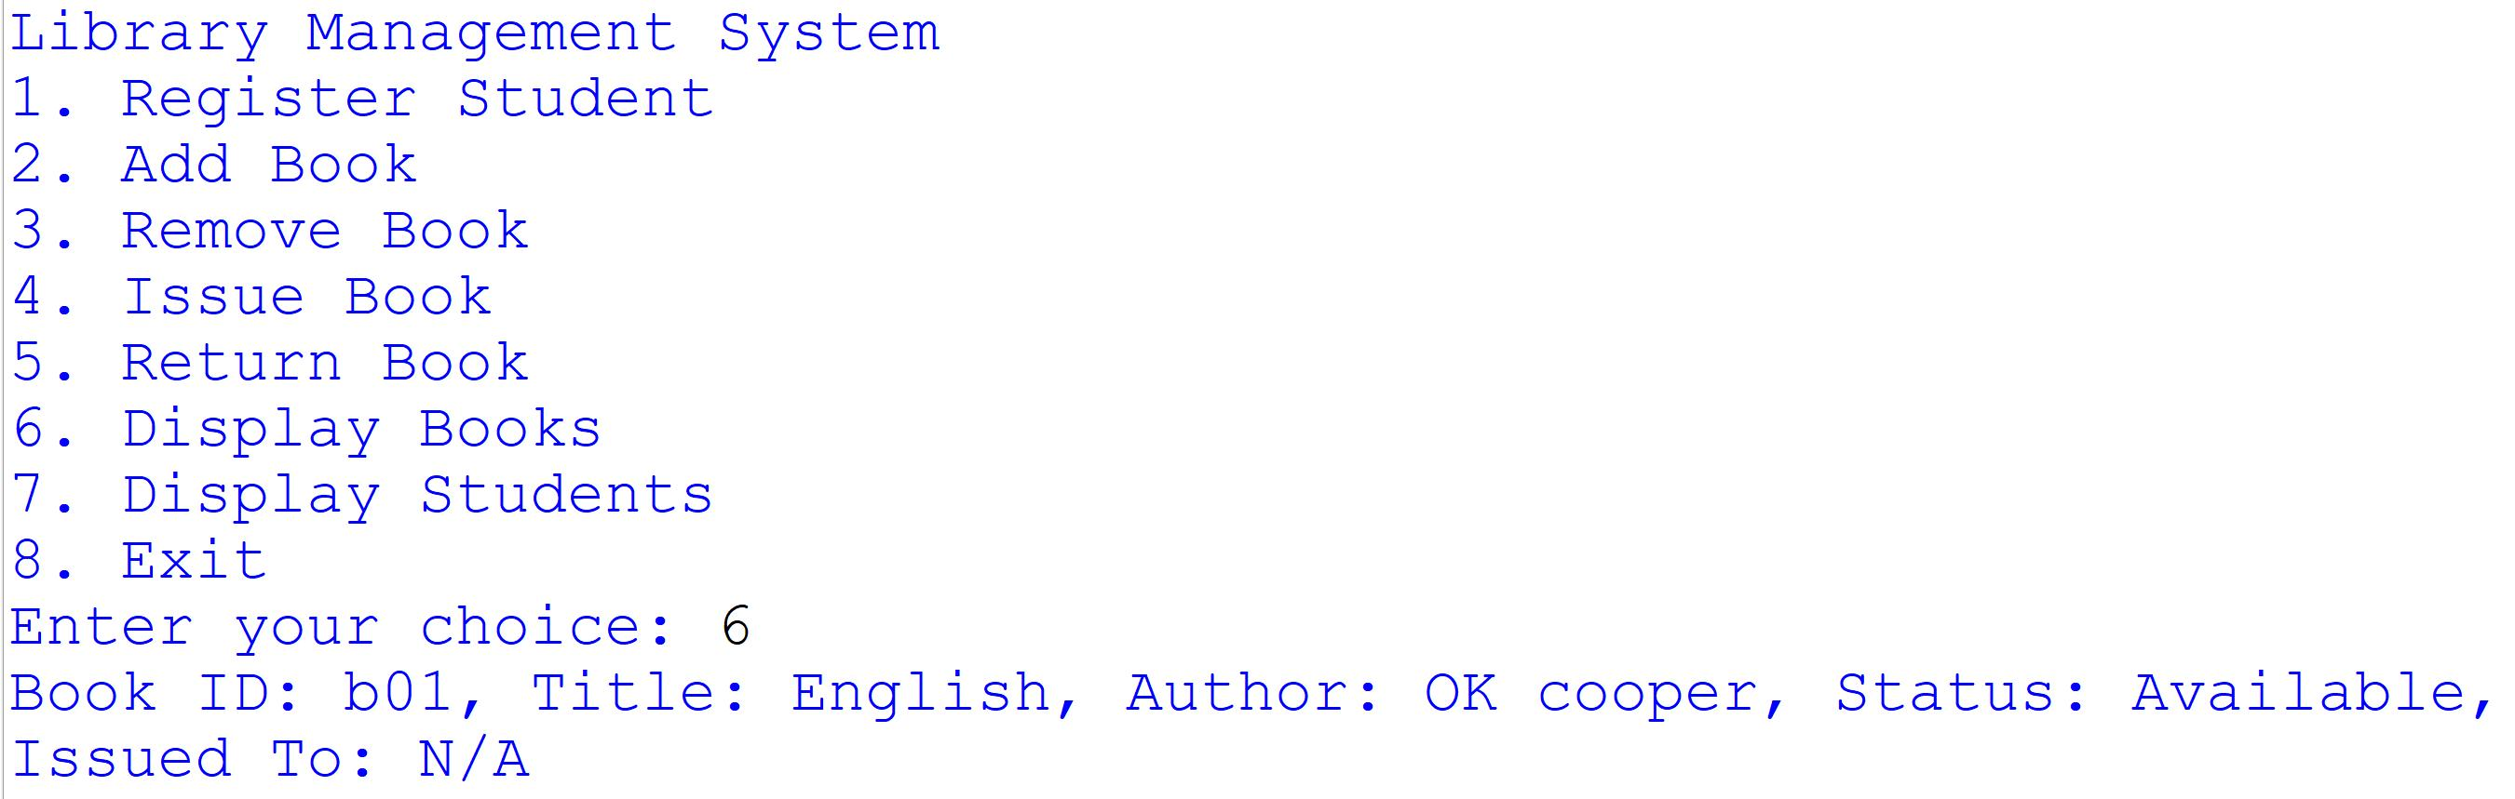
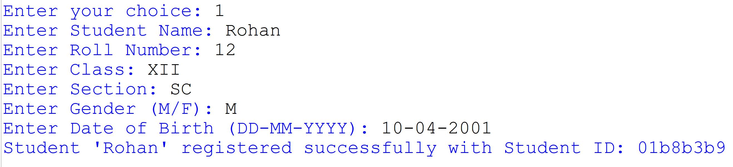
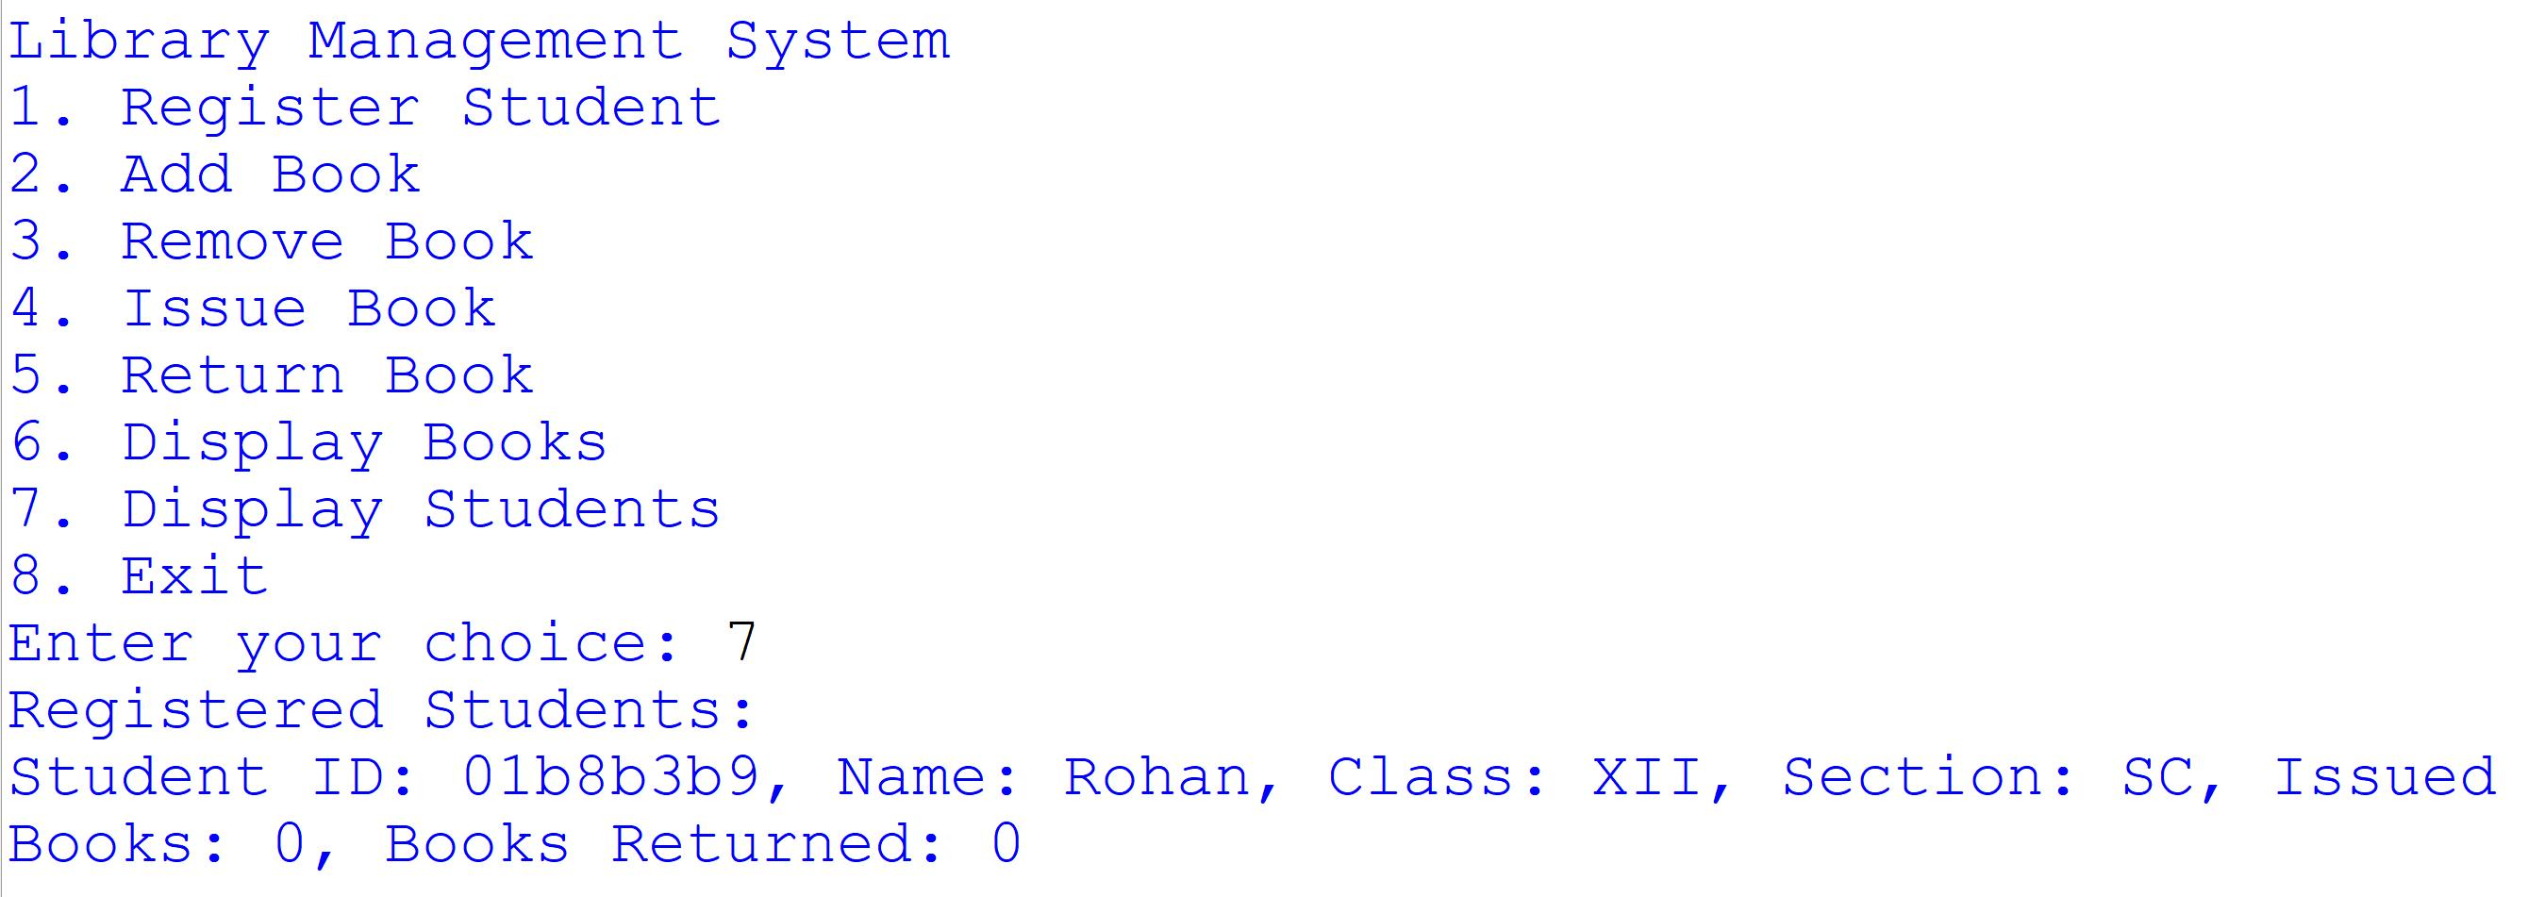
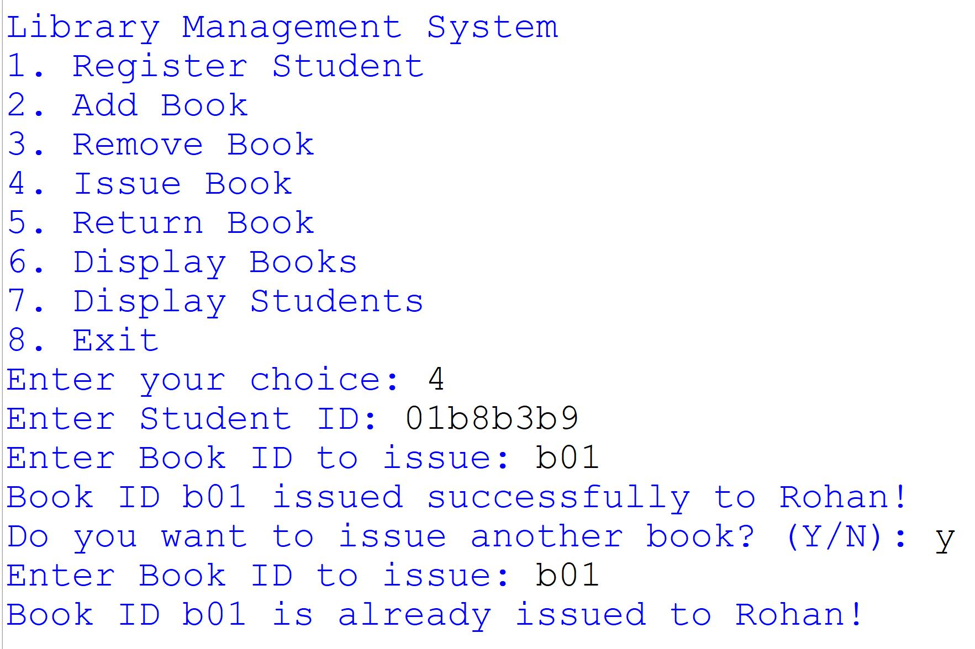
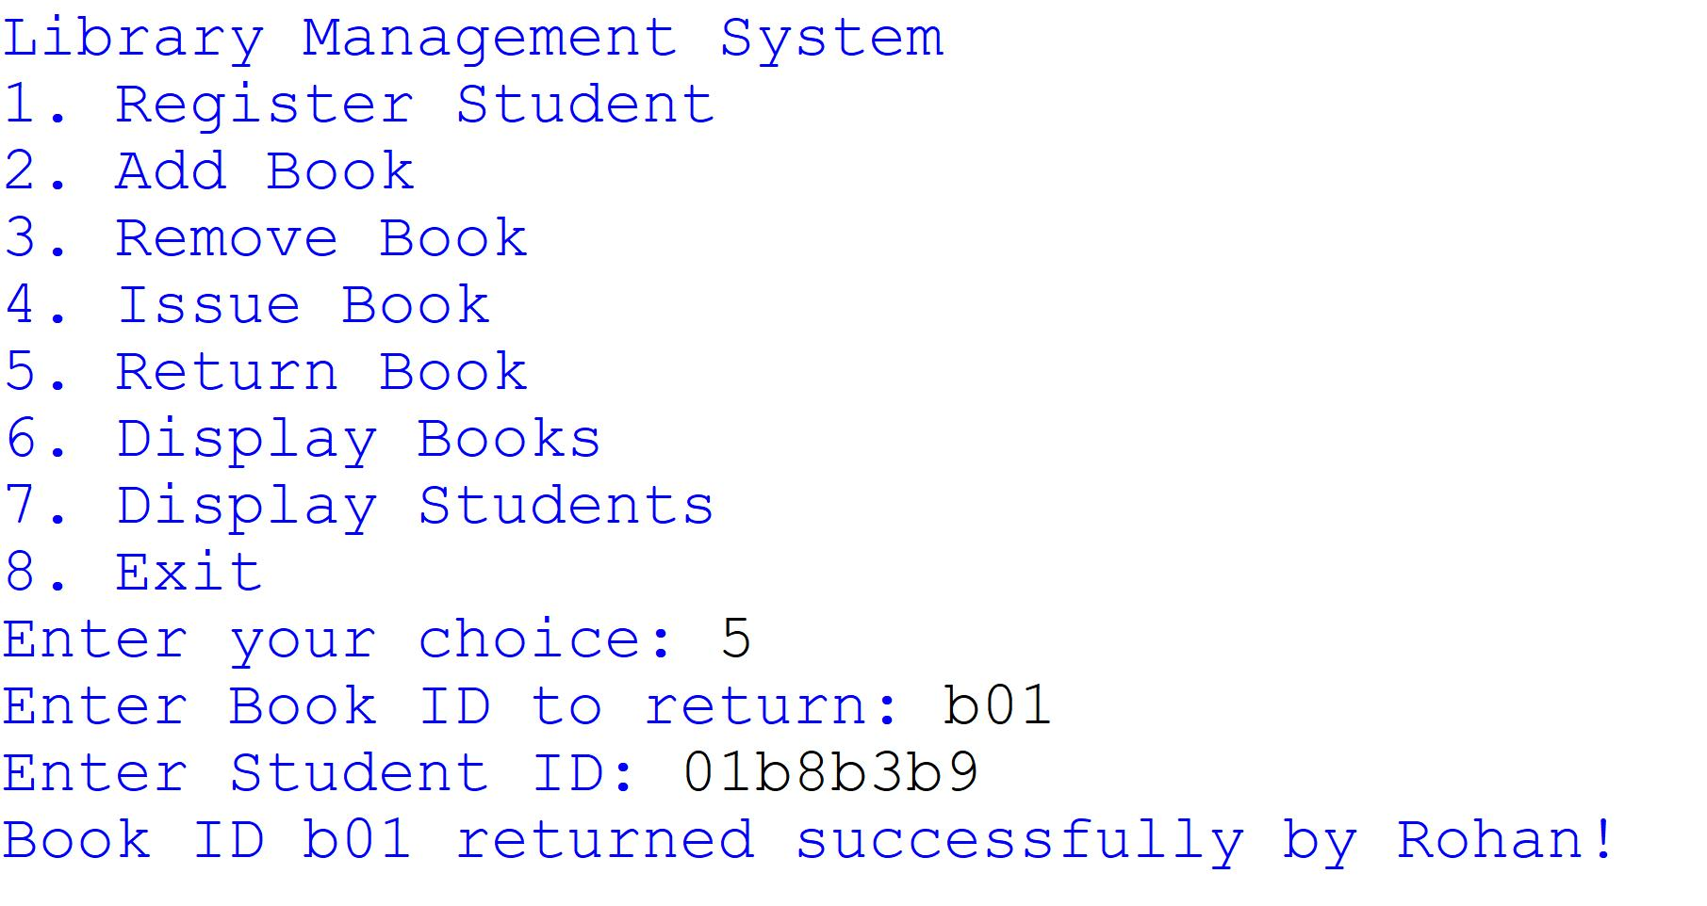

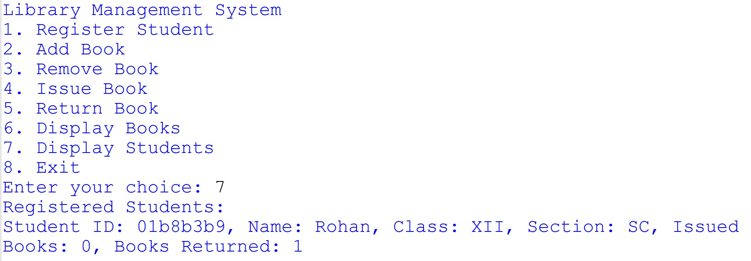

Technological requirements

Software
- Python
- VS Code

Hardware
- Laptop/PC

References

- https://www.python.org/
- UUID Module in Python
- Python OS Module
- https://realpython.com/python-pickle-module/
- https://www.tutorialspoint.com/python-pickling
- https://www.w3schools.com/python/module_random.asp

